# Introduction

Manta Material Priorisierung involves two types of orders from snowflake and API. Berechnung orders from API that are visualized as a gantt chart representation in dashboard, rearrange those orders based on the priority in the planning page and send those rearranged data to the target via API.

Ist-Situation orders from snowflake that are displayed in planning page.

# Application Login

The login page of the application authenticates the user, responsible for orders modification.

Authentication for the application happens via single sign-on.

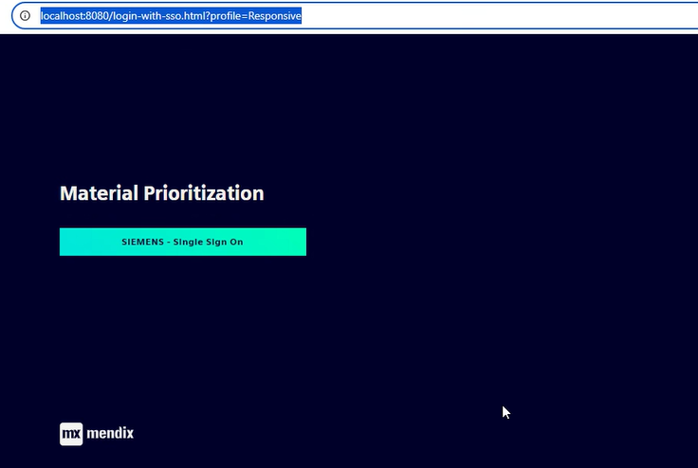*Figure 1 Application login page with multiple options to sign in*

In case of a forbidden message, please contact your application administrator to activate the user account.

There are two ways a user can access to the application:

* The user first signs in via Single Sign-On (SSO), but they will only gain access after an admin approves or grants them admin privileges.
* Alternatively, an admin can create a user account and assign the required access permissions, enabling the user to access the application.

# Application Overview

**How to use the application?**

1. Configure snowflake and import Ist-Sitution orders in snowflake configuration.
2. Configure API and import Berechnung orders in dashboard page. In Dashboard, we can fix the order and also can change the start and end date of the fixed orders.
3. Reorder the Berechnung orders based on priority in planning page.

Information on application login, contents of the application dashboard and details of the navigation menus are discussed one by one.

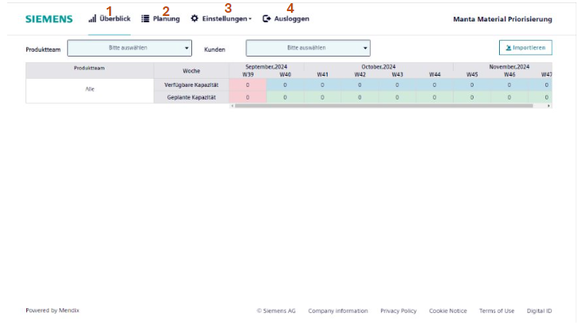*Figure 2 Navigation menu of the application*

|  |  |
| --- | --- |
| **#** | **Detail** |
| **1** | **Überblick**  Visual representation of the orders from API. View Überblickfor more information |
| **2** | **Planung**  Orders from API and snowflake. View planung for more information |
| **3** | **Einstellungen**  Contains other services used in the application. View Einstellungen for more information |
| **4** | **Ausloggen**  Sign out button |

## Überblick

Dashboard contains visual representation of the orders from API.

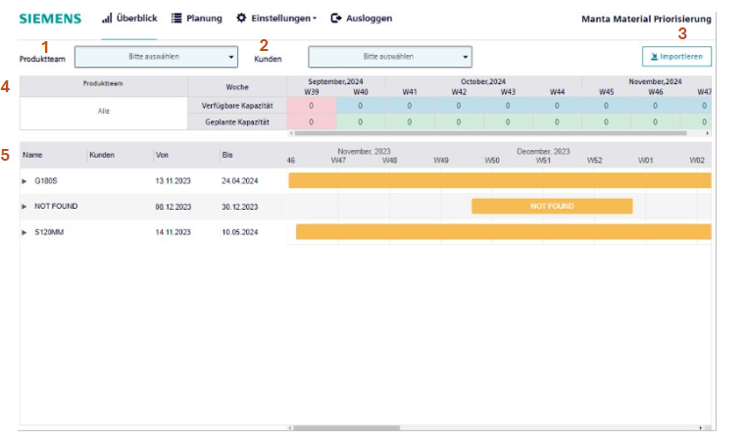*Figure 3 Overview of application dashboard*

|  |  |
| --- | --- |
| **#** | **Detail** |
| **1** | **Produktteam**  Dropdown containing all productTeam. |
| **2** | **Kunden**  Dropdown containing all productTeam. |
| **3** | **Importieren**  Importieren button to import berechnung orders through API’s. |
| **4** | **CapacityTable**  Calculate the available capacity and planned capacity based on the selected dropdown of customer and productTeam. |
| **5** | **Gantt Chart**  Visualize the orders grouped by productTeam based on the selected dropdown of customer and productTeam. |

Dashboard page has gantt chart visual representation of berechnung orders retrieved from API. The gantt chart shows the orders grouped by productTeam based on the selected dropdown of customer and productTeam. Expanding each productTeam all the orders with the corresponsding start and end date in visual.

Check Box for each order represents orderFix. It represents the highest priority of the order. Those orders will be on the top of each week on the planning page. Once the order is fixed, it can change the start and end date of the order.

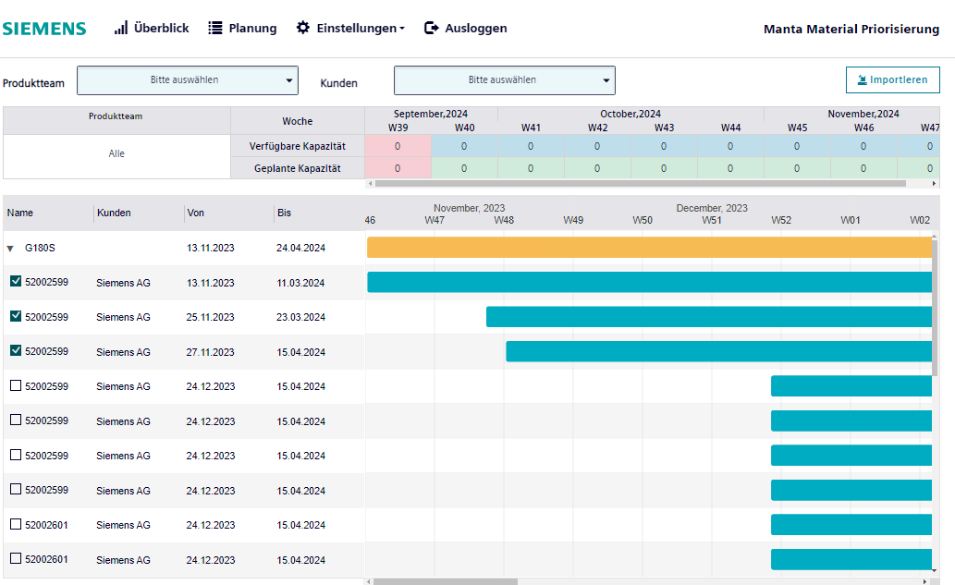*Figure 4 Overview of gantt-chart in dashboard page*

### How to import from dasboard

Upon clicking the Import button, the page will display the input data, which is then sent as a request to the API. After clicking Start, the API triggers, and the Import button in the UI indicates loading.

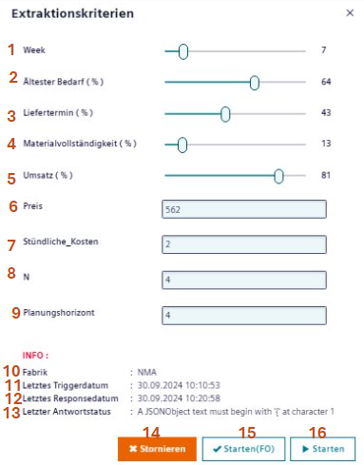

*Figure 5 Overview of import in dashboard page*

Clicking the button again will be displayed with the input data that are not editable, allowing the user to either cancel the request or to close the page.

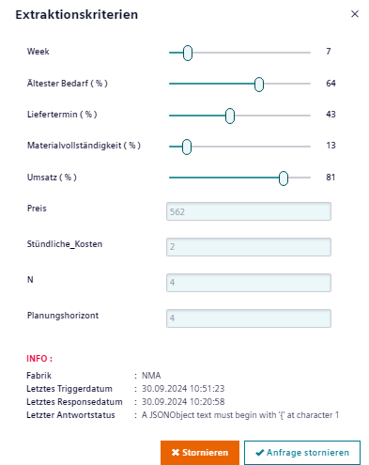

*Figure 6 Overview of import with non-editable inputs*

**Stornieren Button:**

It will cancel the changes and close the page.

**Anfrage stornieren** **Button**:

If the API response is not ready, api request will be cancelled after the delay duration configured in api configuration page.

If not, the request cannot be canceled, and it will return the Berechnung orders.This response includes order number, allocation week, material number, Quantity, order number, start and end date, remaining columns of berechnung orders will merge the columns from Ist-Situation orders based on order number.Retrieved orders will reflect in dashboard and planning page

**INFO**: The info has the details of the last api trigger.

|  |  |
| --- | --- |
| **#** | **Detail** |
| **1** | **Week**  Week in number |
| **2** | **Ältester Bedarf (%)**  Demand in percentage |
| **3** | **Liefertermin (%)**  Delivery date in percentage |
| **4** | **Materialvollständigkeit (%)**  Delivery date in percentage |
| **5** | **Umsatz (%)**  Material completeness in percentage |
| **6** | **Preis**  Price value |
| **7** | **Stündliche_Kosten**  Hourly Cost value |
| **8** | **N** |
| **9** | **Planungshorizont**  Planning horizon |
| **10** | **Fabrik**  Name of the factory (Snowflake schema) |
| **11** | **Letztes Triggerdatum**  Timestamp of last API trigger |
| **12** | **Letztes Triggerdatum**  Timestamp of last response of API trigger |
| **13** | **Letzter Antwortstatus**  Status of API trigger |
| **14** | **Stornieren**  Cancel the API trigger |
| **15** | **Starten Sie FixedOrders**  Start the API trigger with the input json except orderFix |
| **16** | **Starten**  Start the API trigger with the input json including orderFix |

## Planung

The planning page has two sets of order lists based on calendarWeek.

1. **Berechnung orders**

* Berechnung orders are retrieved from API. These orders can be rearranged as per priority within the week.
* Rearrange features include moving the top and bottom of orders within the week and move based on the index value of the orders in a week.
* OrderFix orders are displayed at the top of the week. Those orders can also be rearranged.

1. **Ist- Situation orders**

* Ist-Situation orders are retrieved from snowflake. These orders cannot be rearranged.

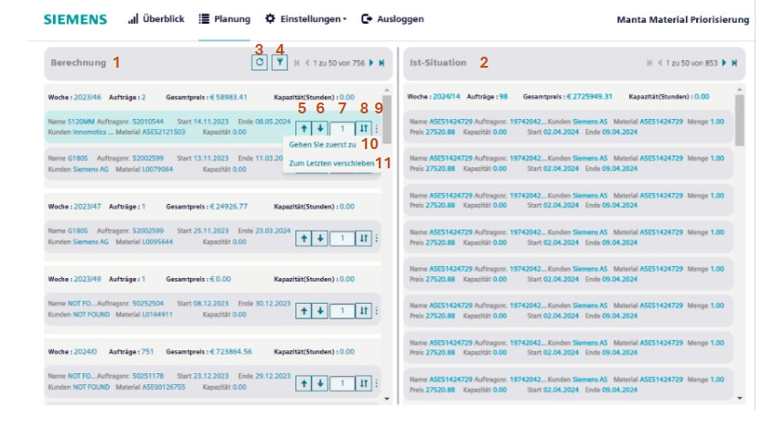*Figure 7 Overview of planning page*

|  |  |
| --- | --- |
| **#** | **Detail** |
| **1** | **Berechnung**  It is an order list from API. These orders can be sorted by the user based on priority. |
| **2** | **Ist-Situation**  It is an order list from snowflake. These orders cannot be modified. |
| **3** | **Reset**  To reset the orderList priority as before. |
| **4** | **Filter**  On click of filter button.    *Figure 8 Planning page with filter*  Based on the ProductTeam, Customer, CalendarWeek dropdown, associated orderList will be displayed on the page. |
| **5** | To move the order up. |
| **6** | To move the order down. |
| **7** | **Index number**  Index number of the order based on calendar week. Can also give the desired index value to the input box within a calendar week |
| **8** | This button will change the orders based on the given index number within a week. |
| **9** | On click of Menu icon popup with move top and bottom appears. |
| **10** | **Move Top:**  It moves order to the top of the calendar week. |
| **11** | **Move Down:**  It moves order to the bottom of the calendar week. |

## Einstellungen

Contains other settings used in the application.

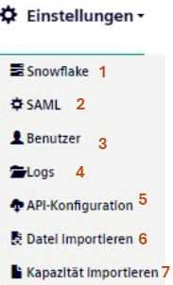

*Figure 9 Overview of Setting menu*

|  |  |
| --- | --- |
| **#** | **Detail** |
| **1** | **Snowflake**  Snowflake configuration |
| **2** | **SAML**  SAML configuration |
| **3** | **Benutzer**  User configuration |
| **4** | **Logs**  Application logs |
| **5** | **API-Konfiguration**  API-Konfiguration to get Berechnung orders |

### How to configure Snowflake

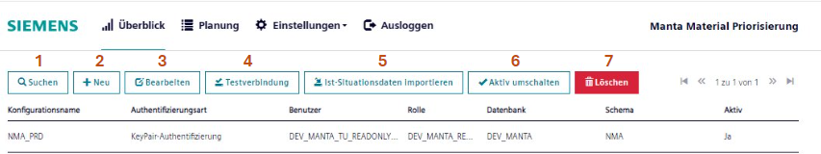 *Figure 10 Overview of Snowflake configuration page*

|  |  |
| --- | --- |
| **#** | **Detail** |
| **1** | **Suchen**  Search snowflake configuration. |
| **2** | **Neu**  Create a new snowflake configuration. |
| **3** | **Bearbeiten**  Edit created snowflake configuration. |
| **4** | **Testverbindung**  To test snowflake connection. |
| **5** | **Ist-Situationsdaten importieren**  Import Ist-Situation orders for active snowflake configuration. View Ist-Situationsdaten importieren for more details. |
| **6** | **Aktiv umschalten**  Snowflake configuration active. |
| **7** | **Löschen**  To deletesnowflake configuration. |

#### How to create Snowflake Configration

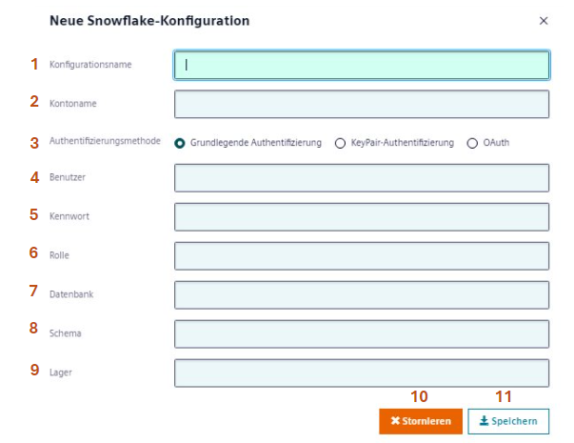

*Figure 11 Create new snowflake configuration*

|  |  |
| --- | --- |
| **#** | **Detail** |
| **1** | **Konfigurationsname**  Name of snowflake configuration. |
| **2** | **Kontoname**  Snowflake account name. |
| **3** | **Authentifizierungsmethode**  Basic authentication, key-pair authentication and no authentication. |
| **4** | **Benutzer**  Snowflake username. |
| **5** | **Kennwort**  Snowflake password. |
| **6** | **Rolle**  User role of the snowflake account. |
| **7** | **Datenbank**  Database of snowflake. |
| **8** | **Schema**  Schema of snowflake. |
| **9** | **Lager**  Warehouse of snowflake. |
| **10** | **Stornieren**  Cancel the snowflake configuration. |
| **11** | **Speichern**  Save the snowflake configuration. |

#### How to edit Snowflake Configuration

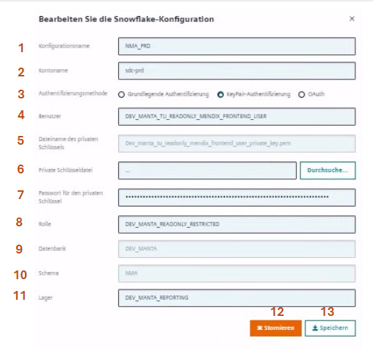

*Figure 12 Edit Snowflake configuration*

|  |  |
| --- | --- |
| **#** | **Detail** |
| **1** | **Konfigurationsname**  Name of snowflake configuration. |
| **2** | **Kontoname**  Snowflake account name. |
| **3** | **Authentifizierungsmethode**  Basic authentication, key-pair authentication and no authentication. |
| **4** | **Benutzer**  Snowflake username. |
| **5** | **Dateiname des privaten Schlüssels**  Name of private key uploaded. |
| **6** | **Private Schlüsseldatei**  Upload new private key file. |
| **7** | **Passwort für den privaten Schlüssel**  Snowflake password. |
| **8** | **Rolle**  User role of the snowflake account. |
| **9** | **Datenbank**  Snowflake database. |
| **10** | **Schema**  Snowflake schema. |
| **11** | **Lager**  Warehuse of snowflake. |
| **12** | **Stornieren**  Cancel the snowflake configuration. |
| **13** | **Speichern**  Save the snowflake configuration. |

#### How to import Ist-Situationsdaten

Import in snowflake configuration is used to get Ist-Situation orders from the given snowflake configuration based on from and to date.

Retrieved Ist-Situation orders will be listed down on the planning page.

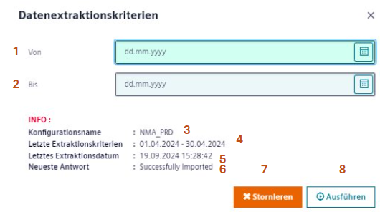

*Figure 13 Import Ist-Situation*

**INFO**: Info has the details of last extraction.

|  |  |
| --- | --- |
| **#** | **Detail** |
| **1** | **Von**  From date value. |
| **2** | **Bis**  To date value. |
| **3** | **Konfigurationsname**  Name of the snowflake configuration. |
| **4** | **Extraktionskriterien**  Last extracted from and to date. |
| **5** | **Extraktionsdatum**  Last imported timestamp. |
| **6** | **Neueste Antwort**  Status of the import. |
| **7** | **Stornieren**  Cancel the import. |
| **8** | **Ausführen**  Start importing data from snowflake. |

After extracting data, list of Ist-Sitaution orders is displayed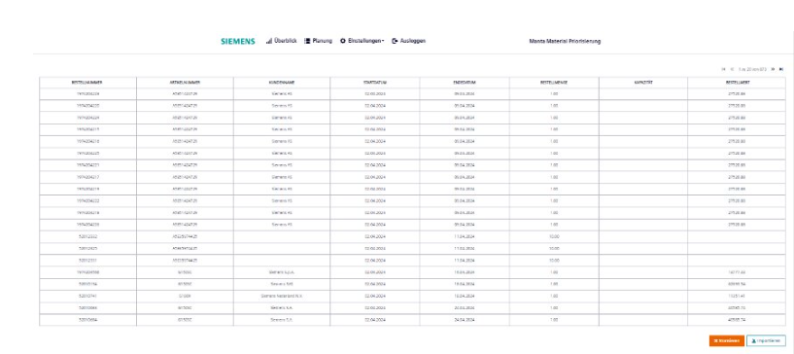 *Figure 14 Retrieved Ist-Situation orders from snowflake*

### Logs

This interface is responsible for displaying application logs.

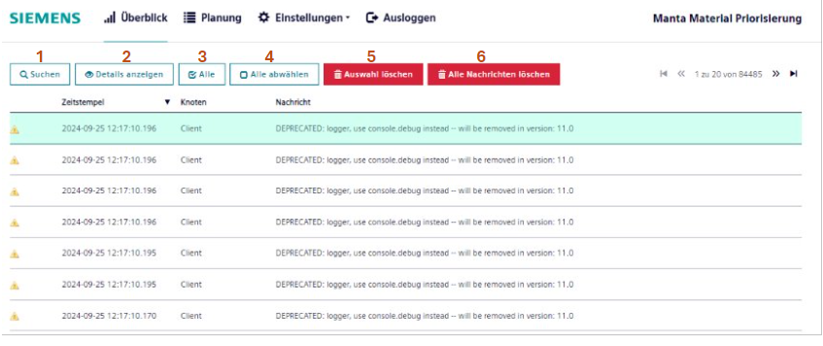*Figure 15 Overview of Application Logs page*

|  |  |
| --- | --- |
| **#** | **Detail** |
| **1** | **Suchen**  Search from the list of log entries. |
| **2** | **Details anzeigen**  View details in a popup dialog for a selected log entry. |
| **3** | **Alle**  Select all entries displayed in the list. |
| **4** | **Alle abwählen**  Deselect all selected entries displayed in the list. |
| **5** | **Auswahl löschen**  Delete all messages from the logging interface. |
| **6** | **Alle Nachrichten löschen**  Delete selected Log entries. |

### SAML

SAML page offers functionalities to configure identity providers and service providers.

SAML module helps to establish authentication to access the application.

To ensure security, the SAML module is enabled only for ”mxadmin” account.

### How to configure Benutzer

The user module provides functionality to manage users to access the application.

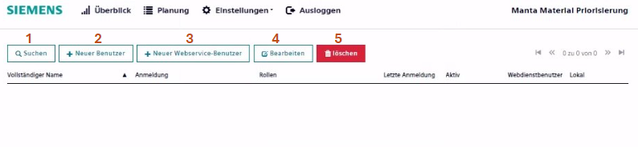*Figure16 Overview of User page*

|  |  |
| --- | --- |
| **#** | **Detail** |
| **1** | **Suchen**  Search from the list of user accounts. |
| **2** | **Neuer Benutzer**  Create new user account. |
| **3** | **Neuer Webservice-Benutzer**  Create new webservice user account. |
| **4** | **Bearbeiten**  Edit existing user account. |
| **5** | **Loschen**  Delete user account |

#### How to create Neuer Benutzer

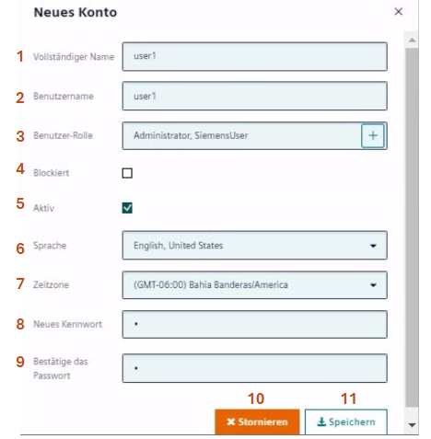

*Figure 17 Create new user page*

|  |  |
| --- | --- |
| **#** | **Detail** |
| **1** | **Vollständiger Name**  Full name of the user. |
| **2** | **Benutzername**  Name of the user. |
| **3** | **Benutzer-Rolle**  Account user role. |
| **4** | **Blockiert**  Check to block the user. |
| **5** | **Aktiv**  Check to make the user active. |
| **6** | **Sprache**  Language of the user configured. |
| **7** | **Zeitzone**  Timezone of the user configured. |
| **8** | **Neues Kennwort**  Create a new password. |
| **9** | **Bestätige das Passwort**  Confirm the created password. |
| **10** | **Stornieren**  Cancel the created user account. |
| **11** | **Speichern**  Save the created user account. |

#### How to create Neuer Webservice-Benutzer



*Figure 18 Create new webservice user page*

|  |  |
| --- | --- |
| **#** | **Detail** |
| **1** | **Vollständiger Name**  Full name of the user. |
| **2** | **Benutzername**  Name of the user. |
| **3** | **Benutzer-Rolle**  Account user role. |
| **4** | **Blockiert**  Check to block the user. |
| **5** | **Aktiv**  Check to make the user active. |
| **6** | **Sprache**  Language of the user configured. |
| **7** | **Zeitzone**  Timezone of the user configured. |
| **8** | **Neues Kennwort**  Create a new password. |
| **9** | **Bestätige das Passwort**  Confirm the created password. |
| **10** | **Stornieren**  Cancel the created user account. |
| **11** | **Speichern**  Save the created user account. |

#### How to Bearbeiten

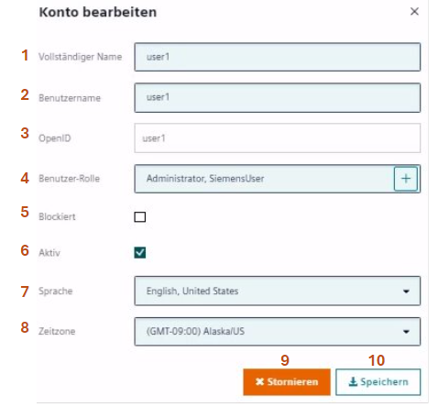

*Figure 19 Edit user page*

|  |  |
| --- | --- |
| **#** | **Detail** |
| **1** | **Vollständiger Name**  Full name of the user. |
| **2** | **Benutzername**  Name of the user. |
| **3** | **OpenId**  Open Id of the user. |
| **4** | **Benutzer-Rolle**  Account user role. |
| **5** | **Blockiert**  Check to block the user. |
| **6** | **Aktiv**  Check to make the user active. |
| **7** | **Sprache**  Language of the user configured. |
| **8** | **Zeitzone**  Timezone of the user configured. |
| **9** | **Stornieren**  Cancel the created user account. |
| **10** | **Speichern**  Save the created user account. |

### How to configure API

### This API configuration helps to fetch berechnung orders in the dashboard.

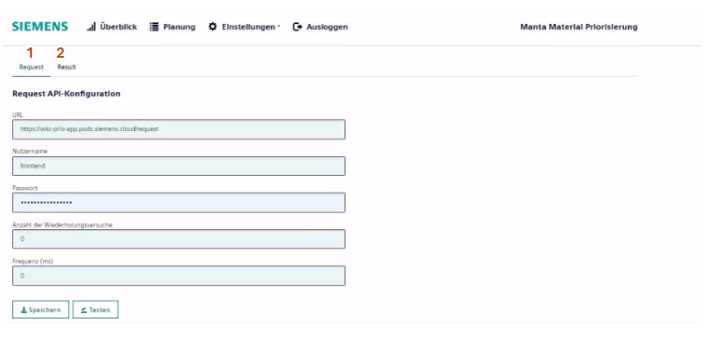*Figure 20 API configuration page*

There is two API to import berechnung orders:

1. **Request API**

This API post data from dashboard import and gives response

1. **Result API**

This API post the response of the request API and results in returning list of berechnung orders

#### Request

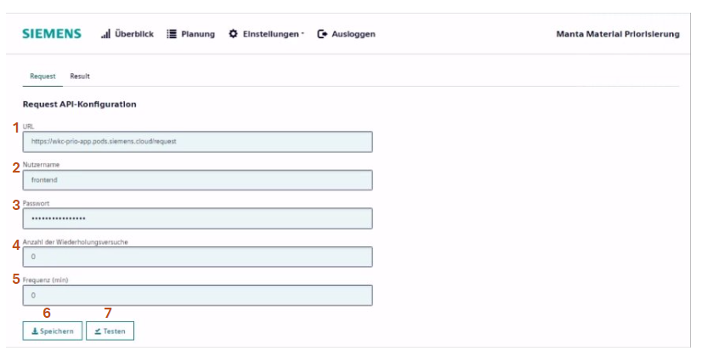*Figure 21 Request API-configuration page*

|  |  |
| --- | --- |
| **#** | **Detail** |
| **1** | **URL**  URL of the API. |
| **2** | **Nutzername**  Username of the API. |
| **3** | **Passwort**  Password of the API. |
| **4** | **Anzahl der Wiederholungsversuche**  Number of retrieves of an API. |
| **5** | **Frequenz (min)**  The frequency of the API to trigger. |
| **6** | **Speichern**  Save the configured API. |
| **7** | **Testen**  Test configured URL is valid |

##### Testen

On clicking the Testen button, the input JSON is sent in the request body.

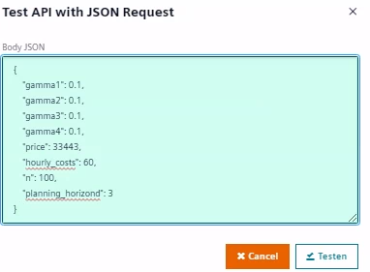

*Figure 22 Request json body of Request API*

Upon testing, the API will return a response.

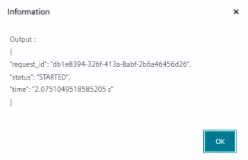

*Figure 23 Response body of Request API*

#### Result

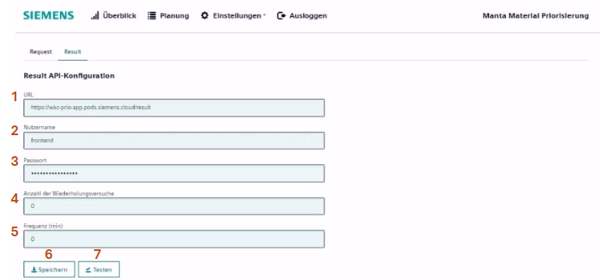*Figure 24 Result API-configuration page*

|  |  |
| --- | --- |
| **#** | **Detail** |
| **1** | **URL**  URL of the API |
| **2** | **Nutzername**  Username of the API |
| **3** | **Passwort**  Password of the API |
| **4** | **Anzahl der Wiederholungsversuche**  Number of retrieves of an API |
| **5** | **Frequenz (min)**  The frequency of the API to trigger |
| **6** | **Speichern**  Save the configured API |
| **7** | **Testen**  Test configured URL is valid |

##### Testen

##### On clicking the Testen button, the input JSON is sent in the request body.

##### 

*Figure 25 Request json body of Result API*

Upon testing, the API will return a response containing a list of orders 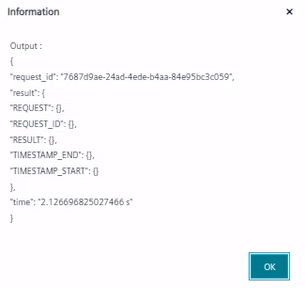

*Figure 26 Response body of Result API*